**Pseudocode:**

**MainMethod**

**Begin**

A ← Value entered in textboxA

B ← Value entered in textboxB

C ← Value entered in textboxC

D ← A + B

**Display** D

E ← B + C

**Display** E

F ← E * D

**Display** F

**End**

**Data Dictionary:**

|  |  |  |  |  |
| --- | --- | --- | --- | --- |
| **Name** | **Purpose** | **Data Type** | **Size** | **Example** |
| vFirstName | Stores the First name of the customer | String | - | Marella |
| vSurName | Stores the sur name of the customer | String | - | Morad |
| vAge | Stores the age of the customer | Integer | 3 | 18 |
| vDOB | Stores the customer’s date of birth | String | 10 | 01/01/2000 |
| vMobNum | Stores the customer’s mobile number | Integer | 10 | 0452369921 |
| vEmail | Stores the customer’s email address | String | - | Marella@gmail.com |

**Mock-Up:**

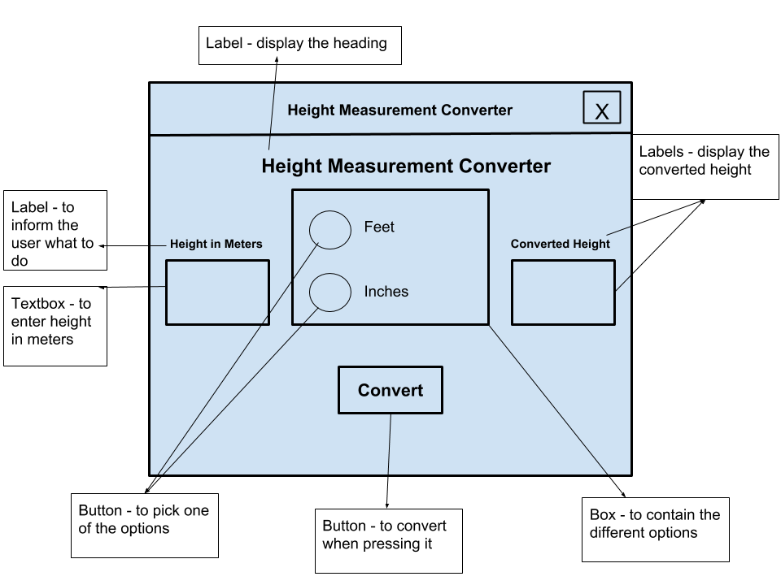

**Object Descriptions:**

**CONTROL: RATBtn**

**PROPERTIES**

Type: Button

Purpose: Allow user to calculate the right-angle triangle’s perimeter and area

Width:?

Text: Right-angle Triangle

Font: Microsoft Sans Serif

Justification: Centre

Visible: Yes

Font Colour: Black

**Methods**

None